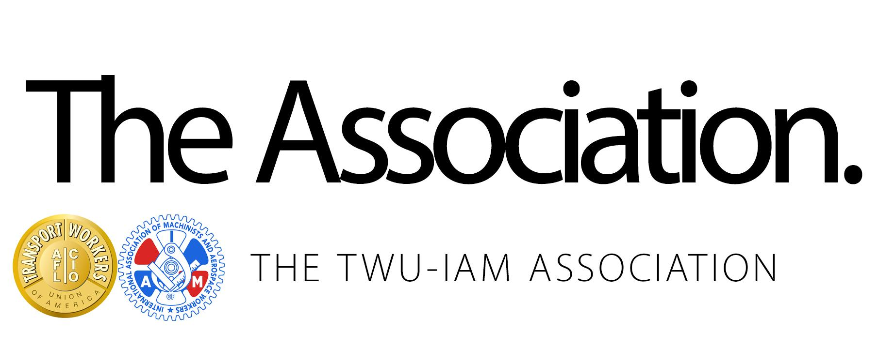
July 26, 2024

All Association Members,

Today, leaders from American Airlines, Inc. reached out to the Association leadership to discuss the possibility of exploring an economics only, short-term extension of existing JCBAs.

American asked to schedule a meeting on August 26th to facilitate those discussions at AA HDQ. As previously announced, we currently have tentative dates for Section 6 contract negotiation openers for the Maintenance and Related, Maintenance Training Specialists, Maintenance Control Technicians, and Material Logistics Specialists groups on August 13th and Fleet Service on August 27th. Those Section 6 opener negotiation dates will need to be delayed based upon this request from the company.

After the discussions with American Airlines in late August, the Association leadership will communicate any proposed economics with the respective Contract Negotiating Committees. Based upon the outcome of the proposed economic discussions, the Association will take appropriate actions.

The Association will continue to collaborate with the respective Contract Negotiation Committees and will keep the membership informed of all progress as it unfolds.

Thank you for your continued confidence and support.

Fraternally,

Your TWU-IAM Association Negotiation Committee

