
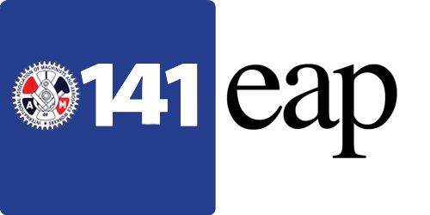
HELPING
HANDS

Consumer Finance Protection Bureau (CFPB)
www.consumerfinance.gov

The Consumer Financial Protection Bureau is a U.S. government agency dedicated to making sure you are treated fairly by banks, lenders, and other financial institutions.

The CFPB is chartered to protect and educate American citizens about financial matters. There are many resources on the website that can help with financial issues. Listed below are links to a variety of resources you can use:

Guides For Financial Decisions
These guides help you understand and plan for big financial goals:
- Buying a house
- Disasters and emergencies
- Filing your taxes
- Getting an auto loan
- Helping a loved one manage their money

Consumer Education

Resources for Yourself, Resources for Helping Others, Coronavirus Resources, Consumer Complaint, Database, Auto Loans, Bank Accounts & Services, Credit Cards, Credit Reports & Scores, Debt, Collection, Scams, Money Transfers, Mortgages, Payday Loans, Prepaid Cards, Reverse Mortgages Student Loans, Guides to Help You Plan For Big Financial Goals, Submit a Complaint, Tell Your Story, Order free brochures, Browse Ask CFPB

Data and Research Resources

Reports, Research Hub, Consumer Complaint Database, Mortgage Database (HMDA), Small Business, Lending Database, Public Data Inventory, Consumer Credit Trends, Mortgage Performance Trends, Financial Well-Being Survey, Credit Card Surveys & Agreements, Prepaid Account Agreements

Find Answers to Your Questions
Browse by money topic to find answers to commonly asked financial questions. Learn the basics, understand key terms, and find ways to act when you have an issue.

Browse Answers to Hundreds of Financial Questions
Ask CFPB Auto loans, Bank accounts and services, Credit cards, Credit reports and scores, Debt collection, Fraud and scams, Money transfers, Mortgages, Payday loans, Prepaid cards, Reverse mortgages, Student loans

Frauds and Scams

Common Types of Scams
Scams are constantly changing. You can protect yourself by knowing what to look out for. Read more
How to Protect Yourself and Others from Fraud and Scams
Fraud and scams can happen at any time and any place. It’s important to know the warning signs. Read more
Understanding Identity Theft
Identity theft occurs when someone steals your personal information to commit fraud. No matter how much goes missing, you should take action. Read more


The heart and soul of the District 141 Employee Assistance Program is the local lodge EAP peer coordinator. These dedicated men and women volunteer their personal time to assist other union members and their families who are experiencing personal difficulties. EAP peer volunteers do not make clinical diagnoses or clinical evaluations; however, they are trained to make a basic assessment of your situation and refer you to an appropriate resource for a more detailed evaluation. EAP peer volunteers will follow up to ensure you have been able to access services that address the difficulty you were experiencing.
Take action

How-to guides

- How to get help if you are the victim of a scam

- How to manage someone else’s money responsibly

- How to spot the classic warning signs of fraud and scams

- Explore how-to guides

