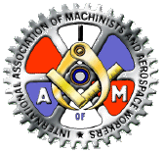
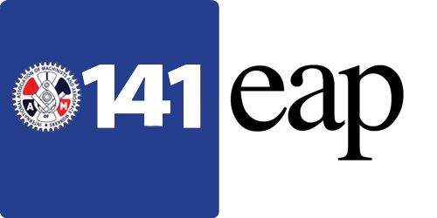
HELPING
HANDS

Cultural Awareness

(Excerpts from rallybright.com by Team RallyBright in Team Dynamics September 21st, 2021)
Cultural awareness refers to the ability of an individual, team or organization to recognize and appreciate cultural differences to successfully interact with people from other backgrounds.
According to the National Center for Cultural Competence, cultural awareness can be defined in one of two ways. First, cultural awareness is understanding, recognizing, and observing both the similarities and differences between multiple cultures.
Second, cultural awareness is a way to see how a person's behavior is impacted by their culture. It's essential to value and understand different cultures to be competitive in a diverse business environment and to thrive in an increasingly global world.
For example, if you're an American business owner, and you want to go to Germany to meet with a customer, you need to know a little more about their culture. In German culture, it’s extremely frowned upon to be late to a meeting. You don't want to offend and possibly lose a client because you are unaware of certain cultural differences.
When you're more culturally aware, it's easier to cultivate an inclusive and more productive environment, where everyone can work as a cohesive team. Understanding other cultures is important because it helps you adapt and adjust the way that you interact with others.
Globalization has made the world a smaller place where we interact with people from different cultures every day. When you become educated about other cultures, it helps strengthen relationships and creates mutual respect between all parties involved.
What Do We Mean by "Culture"?

Culture is made up of a wide variety of characteristics and knowledge of a particular group of people, and spans a person's race, geophysical location, religion, values, musical tastes, language, and family history, to name a few. All these factors influence the way you act, speak, and react to others.
The term "culture" refers to a group's shared norms of behavior and attitudes. Understanding this means understanding that people from diverse backgrounds can have comparable ways of thinking about their own experiences, making communication easier, despite superficial difference. Because different cultures may hold different cultural beliefs, the meaning behind various events might be vastly distinct depending on their culture.
Cultural awareness makes it easier for you to understand the influences that have created the mindset of another person and their actions.
Why Is Cultural Awareness Important?
Seeing the world through the eyes of others helps mitigate the impact of implicit biases, which develop over the course of a lifetime through life experiences, family biases, media, and cultural messages. This approach, which means to take another person’s perspective, enables you to treat that person the way you would want to be treated if you were them and in the exact same circumstances. Doing this with everyone produces better outcomes.
Believe that what others think matters; give them the chance to explain their perspectives and express their points of view; actively listen to understand them.
Developing Cultural Awareness

To develop cultural awareness, you must be open to learning how others view the world and why. It's important that you are receptive to understanding and respecting cultural differences. This can help you empathize with others. Together you can create an inclusive and compassionate work environment. Develop cultural awareness by:

Open Communication
Strive to foster an environment where everyone feels safe and valued when they express their thoughts and views. It's also a good idea to have an open-door policy for anyone who feels offended or misunderstood.


Observe and Listen
When you're working with employees, teammates, and customers from different cultures, you can learn a lot by observing them and listening to what they say.
In time, it's a good idea to discover the underlying reasons why they do and say things the way they do. A more diverse team has a lot to bring to the table, and you want them to share their ideas and culture to help make positive changes.


The heart and soul of the District 141 Employee Assistance Program is the local lodge EAP peer coordinator. These dedicated men and women volunteer their personal time to assist other union members and their families who are experiencing personal difficulties. EAP peer coordinators do not make clinical diagnoses or clinical evaluations, however, they are trained to make a basic assessment of your situation and refer you to an appropriate resource for a more detailed evaluation. EAP peer coordinators will follow up to ensure you have been able to access services that addressed the difficulty you were experiencing.

Celebrate Holidays and Events

When you're working with a group of people, you can develop cultural awareness by encouraging open communication and a safe environment where people can talk about holidays important to their culture and when appropriate, even celebrate together. When you celebrate or recognize holidays and events of other cultures, it helps make your team more aware of other traditions and creates sensitivity to their differences. When you explore others holidays and traditional celebrations, you understand each other’s heritage.

