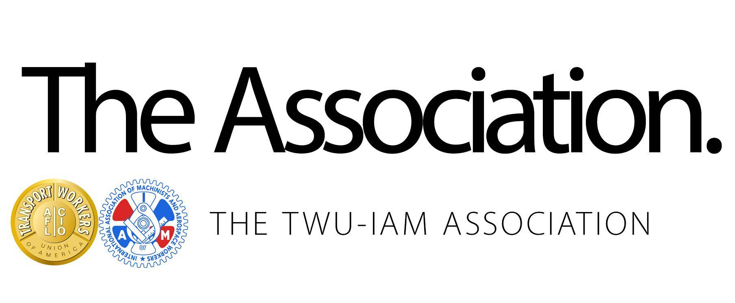
Agreement in Principle Highlights: Fleet Service
As stated in the announcement bulletin to members, the complete text of the JCBA will be available before ratification voting commences. An information meeting and ratification schedule is being developed and is forthcoming.

Wage Increases | Fleet Service: DOS +4.8%. +2% at +12,24,36,48 months after date of signing  CLP: DOS +3.9%. +2% at +12,24,36,48 months after date of signing
Profit Sharing | Top of industry profit sharing formula: 10% of first $2.5 billion of pre-tax income, 20% of pre-tax-income above $2.5 billion.
Premiums | Crew Chief Premium: DOS: $2.20/hr. DOS+3: $2.40/hr.  Shift Differentials: .51, .58, .61 cents per hour;  Hub Control Center Premium: $3.20 per hour
Signing Bonus | $3,000
Scope and Job Protection | All employees have system and station job protection in their current status (full and part-time);  Increased permanently staffed stations from 40 to 45;  Secured express bag transfers from mainline in the following locations: PHL, CLT, PHX, DCA, LGA and LAX;  Secured cargo work at the following locations: DFW, JFK, LAX, MIA, ORD, PHX and LAS;  Secured catering in CLT and PHL until the end of the agreement;  Secured de-icing in the following locations: BOS, DCA, JFK, LGA and ORD;  Secured lavatory and water servicing of aircraft in 35 locations
Medical: All Association Members | Standard: The Standard plan’s current design and employee contribution will remain the same as described in the JCBA;  Core: The Core plan will be available with the cost share outlined in the JCBA. The plan design can be modified at the company’s discretion;  High Cost Coverage (formerly “Value”): No change. May be available at the company’s discretion and is NOT part of the JCBA;  HMO: HMO plans may be available at the company’s discretion and is NOT part of the JCBA.  Me-too: Standard and Core plans me-too with other AA groups on plan design and cost share improvements.
Medical: IAM-represented Association members | PPO 80: Will retain the PPO 80 Plan with the same plan design and premium share;  PPO 90: Will retain the PPO 90 Plan with the same plan design and premium share through 2025  PPO 100: Will retain the PPO 100 Plan with the same plan design and premium share through 2020
Retirement: IAM represented Association Members | IAM National Pension Plan (IAMNPP): Increased IAMNPP contributions to the equivalent of 5% of total pay; and  401(k) Match: 100% match up to 4% of total pay;
Retirement: TWU represented Association members | 401(k) Employer Contribution and Match: Automatic 5% contribution of total pay and 100% match up to another 4% of total pay.
Retiree Benefits: All Association Members | HRA for Retiree Benefits: If retirement eligible, employee may elect to receive 50% of hourly pay rate for each unused hour in sick leave bank deposited into HRA for use in paying for retiree benefits in lieu of $9.20/hr cash pay out.
Vacation | The following vacation schedule will take effect on DOS: Completion of 1 year, 2 weeks; 4 years, 3 weeks; 11 years, 4 weeks; 24 years, 5 weeks; 29 years, 6 weeks;  The following vacation schedule will take effect on DOS + 3: Completion of 1 year, 2 weeks; 4 years, 3 weeks; 11 years, 4 weeks; 17 years, 5 weeks; 24 years, 6 weeks;  Any Association member who is entitled to an increase in vacation during 2020 will receive a lump sum payment for such vacation.
Holidays | 10 holidays;  Double-time and a half if worked;  If off, 8 hrs paid straight time;  Ability to comp holiday up to a max of 140 hrs
Overtime | Minimum one hour of OT;  New double-time language after 12 hours on any work day;  Paid OT bypass at the applicable rate
Sick Leave | Accrue 10 sick days per year;  OJI first 20 days paid in full by company. After 20 days, employee may use accumulated sick bank to supplement worker’s compensation;  Sick leave bank maximum increased to 1600 hours;  Upon separation from the company, a one-time cash payout in the amount of $9.20 for each unused hour in sick leave bank
Hours of Service | Adverse weather conditions language;  OT pay for working through lunch;  Meal period rescheduled;  Airport facility closure language
Training | Enhanced meal per diems for training;  Enhanced travel time language;  Web base training language;  SIDA Badge: Enhanced language regarding SIDA badge acquisition.  For more information, Please visit TWU-IAM.org

