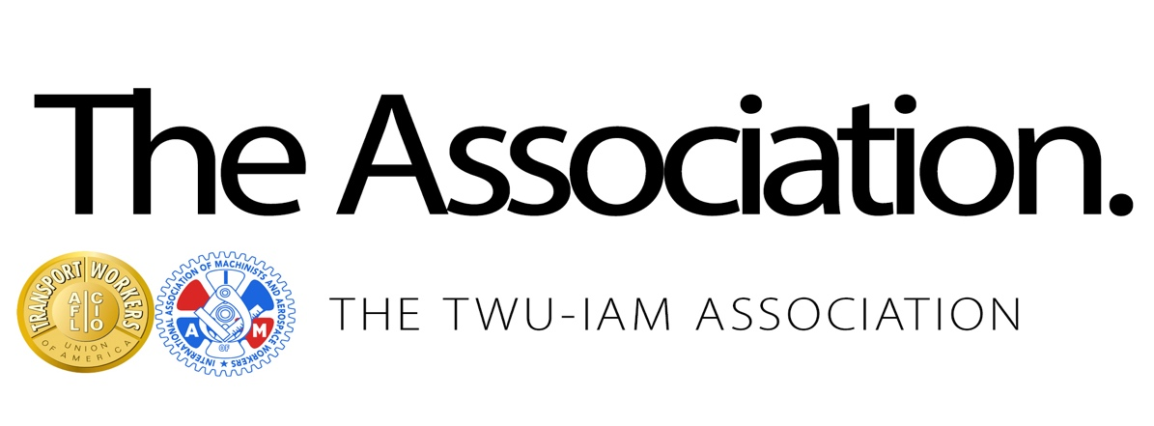
January 30, 2020
Agreements in Principle
Sisters and Brothers,
After more than four years of bargaining, the TWU-IAM Association is proud to announce we have reached Agreements in Principle with American Airlines for five new joint collective bargaining agreements (JCBAs) worth $4.2 billion, covering more than 30,000 Mechanic & Related, Fleet Service, Maintenance Control, MLS/Stores and Maintenance Training Specialist members.
The Association negotiating committees must finalize and proof contract language on agreed upon provisions of the tentative contracts, and the parties will continue to meet to accomplish that task. This process could take a few weeks. Preliminary highlight sheets are attached to this bulletin, but the final, complete contract language will be available to all members. In addition to being posted on union websites, the complete agreement will be mailed to each member’s home before voting begins.

After the final language is finalized, membership ratification details and voting information will be announced.

When negotiations began, the Association negotiating committees were faced with the tremendous challenge of combining dissimilar, mature contracts negotiated by different unions with different airlines into JCBAs for the new American Airlines. From the outset, we had a decision to make: get a quick agreement, or get the right agreement for Association members, regardless of how difficult, lengthy and contentious that process would be. As you review the complete terms of the contracts, you will see that we chose the correct path.

Your negotiating committees recommend ratification of these agreements.

These Agreements in Principle will provide all Association members with wages, benefits, work rules, job security and retirement income that had never before been accomplished. Total compensation (wages, premiums, retirement, and profit sharing) is the richest in the industry. Not only are all Association members’ jobs protected in their locations, but more importantly, we were able to protect the work we do. The considerable benefits to all members will be immediately apparent.

Nothing in these Agreements in Principle would have been possible without the support, solidarity and patience of the membership. We ask for your continued patience as we complete and proof every word so you can be presented with all the information you need to make an informed decision when you vote on ratification.

Please Post on All TWU- IAM Bulletin Boards

