Free, Professional, Confidential

Debt Management

Depression / Anxiety

Grief & Loss

Eating Disorders

Divorce

Marital Relationships

Child / Teen Conduct

Elder Care

Alcohol / Drug Dependence

Gambling

Addictive Behavior

Sexual Abuse

Domestic Violence

Trauma Reaction

Stress Management

IAM District 141 EAP
Main Office/All Stations & Work Areas
Mark Sanderson, NCAC, LAPC, CEAP
Phone: W 773-601-5081 C 815-505-4790
msandersoneap@gmail.com

ORDCG
Jay Austin, Henry Klein, Beth Doocy, Liane Wilson
Reva Meadows, Scott Williams, Kathy Dvorak
ORDJL
Couki Gaskins, Cynthia Buggs, Dominic Maratto
ORDCS
Sue Briton-Opitz, Felicia Gaines, Marvin Harris, Kris Treder
CLE
Patty Levstik
pattylevstik@gmail.com
CHIRR/CHIBD
847-427-4020
Char Wiggins, David Bryk, Linda Splinter, Charlene Allen
DTW AT HOME RESERVATIONS
Lisea Billingslea
Irtbill@sbcglobal.net
FLL Airport Terminal
Marie Dominguez-Diaz
mdominguez0707@yahoo.com
PIT Airport Terminal
Sheila Sonsino
sheila143143@yahoo.com
STL Airport Terminal
Scott Ross
TPA Airport Terminal
Chuck Krieg
ckrieg57@gmail.com
WHQ (Willis Tower)
847-700-3713
Wissam (Sam) Jameel

MSP, RSW

If above phone # not listed look up in work area or contact:
Midwest & Florida Region Representative Mark Sanderson:
773- 601-5081
E-mail: msandersoneap@gmail.com

Offering Our Members Confidential
Free Guidance to Professional Help

EMPLOYEE
ASSSISTANCE
PROGRAM



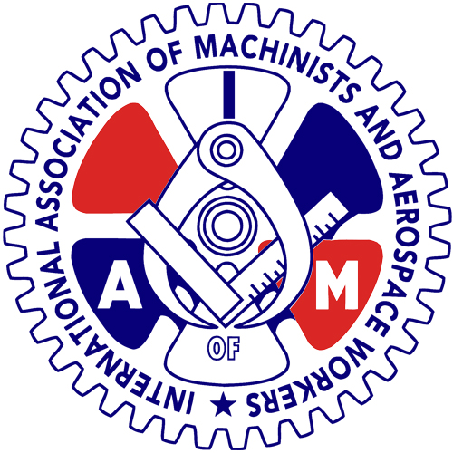

MIDWEST & FLORIDA REGION
CLE DTWRRA FLL MSP ORD PIT RSW STL TPA

IAM EAP
Geared to Help

(Revised June 29, 2017)
Is EAP Right for You?

What Is The Employee Assistance
Program (EAP)?

Everyone faces challenging personal problems at some point in their life.

The International Association of Machinists (IAM) offers a program that is helpful during difficult times. IAM District 141 EAP offers confidential and free help for union members and their families when they are faced with the problems life can present.

How Do I Know When I Really Have
A Problem?

We all have ups and downs.

It’s not easy to decide when to ask for support. Your EAP coordinator can help you determine whether you need to take action. It’s always better to deal with a problem before it becomes overwhelming.

Here are some questions to help determine whether you may need help:

Do I think about a problem frequently; am I always worried about the something?

Am I just telling myself the problem isn’t
“that bad” and that it’ll just go away; but it
doesn’t?

Do I feel tired, depressed, frustrated,
angry or sick?

Is my job performance or dependability
being affected?

Do I feel like giving up?

What Services Does The EAP Provide?

Your IAM EAP coordinator will listen to your situation and assist you in developing a plan of action that
will meet your needs. If necessary, you will be referred to qualified service providers in your community. The IAM EAP coordinator will also follow up with you to ensure that you are getting the help you need, that you are satisfied with the referral and that your issue(s) are being resolved effectively.

Problems The
EAP Can Help You Address:

The EAP has access to mental health and substance abuse
Professionals who are experienced with helping employees deal with a wide range of personal problems.

Depression / Anxiety
Grief & Loss
Alcohol / Drug Dependence
Gambling
Addictive Behavior
Sexual Abuse
Divorce
Debt Management
Elder Care
Trauma Reactions
Domestic Violence
Eating Disorders
Child / Teen Conduct
Marital Relationships

What Will This Cost?
The services of the IAM EAP are free. If referral to a community service provider is necessary, your EAP
Coordinator will work with you to make effective use of any health insurance benefits.

Is the EAP Really Confidential?

The EA Program is confidential. Occasionally, there are circumstances that require help from resources within our communities. When this is necessary, we will discuss the situation with you, get your consent to speak with the resource and follow-up with the resource. Confidentiality is the cornerstone of the IAM EAP program. There are limits dictated by law that (in certain circumstances), require that confidentiality be broken, usually when there is a threat to someone in danger of harm.

The EAP is Free and Voluntary

The Employee Assistance Program is voluntary.
You decide whether or not you follow the recommendations.

The IAM/UAL EAP
IAM District 141 and United Airlines operate an EAP. Help is available not only through the IAM, but also through a program provided by the Company. Members are free to seek assistance from either program. To determine if consultation with a United Company EAP representative is appropriate, contact the regional office of the IAM EAP:

773-601-5081

The Next Step Is to Call
Pick up the phone; seek out any of the IAM
EAP coordinators noted in this brochure, or just call the main IAM EAP number above. A simple phone call is the first step toward problem resolution. Do it today!

IAM District 141Employee Assistance
Program
Mark Sanderson, NCAC, LAPC, CEAP
Midwest & Florida Region Representative
Chicago O’Hare Airport (ORD)
Phone: W 773- 601-5081 C 815-505-4790
msandersoneap@gmail.com

